
Hello Psychology instructors!

We created this document to help you find the Worth Publishers books that might be appropriate for your courses. We have linked the titles to our online catalog (everything in blue type is a link), where you can find more information and tables of contents. We hope this will help you review more efficiently and find the books that fit your needs. We would be happy to send you any of these books to review. You can browse our catalog online at www.macmillanlearning.com/Catalog/discipline/Psychology.

Additionally, be sure to check out LaunchPad, our online learning environment that helps students and instructors plan, learn, and succeed with their Psychology text. With such features as pre-built teaching units, powerful adaptive quizzing (visit learningcurveworks.com), multimedia content, gradebook, and social commenting capabilities, LaunchPad sets the entire classroom up for success! Visit launchpadworks.com for more information

Please let us know if we can help in any way. Thank you!

Supplemental Texts 3
Developmental Psychology 5
Developing Lives 5
Child Development 5
Lifespan Development 6
Theories of Development 7
Abnormal Psychology 7
Abnormal Psychology 7
Experimental Psychology 9
Research Methods 9
Behavioral Statistics 9
Biological Psychology & Neuroscience 10
Introduction to Biological Psychology 10
Human Neuropsychology 11
Drugs and Behavior 11
Behavioral Genetics 11
Social & Personality Psychology 12
Social Psychology 13
Special Topics in Social Psychology 13
Cognition, Learning & Memory 13
Cognitive Psychology 14
Learning and Memory 14
Judgment & Decision Making 15
Animal Psychology 15
Language 15
Sensation & Perception 15
Sensation & Perception 15
Forensic & Legal Psychology 16
Forensic & Legal Psychology 16
Industrial & Organizational Psychology 16
Industrial & Organizational Psychology 16
Health Psychology 17
Health Psychology 17
Evolution 18
Evolution 18

Supplemental Texts
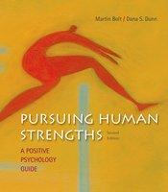
Bolt, Pursuing Human Strengths: A Positive Psychology Guide, 2e
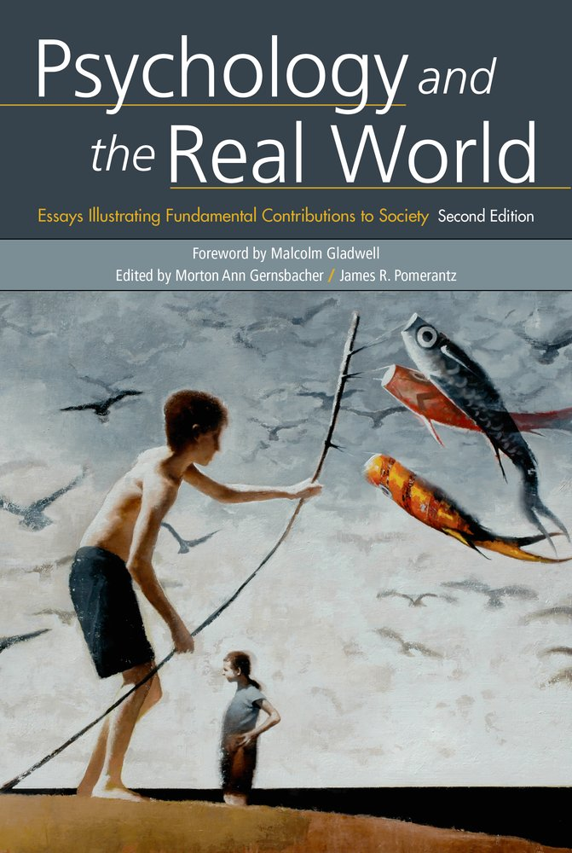
Pursuing Human Strengths gives instructors and students the information and strategies they need to understand the field of positive psychology and to put what researchers in the field have learn to effective use in their own lives. The new edition welcomes coauthor Dana Dunn, who shares Martin Bolt's passion for exploring and teaching positive psychology. Their engagingly written update includes over 175 new references, reflecting the continuing expansion of the scientific literature in positive psychology, as well as updated exercises and activities throughout. Pursuing Human Strengths can serve as a core text for courses in positive psychology and well-being and can also serve as a great accompaniment to virtually any psychology course (most notably, human adjustment and growth, introductory psychology, and abnormal psychology.
Foundation for the Advancement of Brain and Behavior Science (FABBS), Psychology and the Real World: Essays Illustrating Fundamental Contributions to Society, 2e
This reader is a collection of brief, personal, original essays in which leading academic psychologists describe what their area of research has contributed to society. Throughout the second edition, authors have updated their articles with new findings and insights. For example, Henry Roediger, Kathleen McDermott, and Mark McDaniel discuss new research that shows taking notes by hand leads to greater comprehension and memory than typing on your computer.

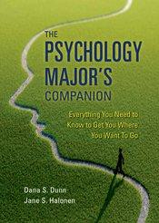
Dunn/Halonen, The Psychology Major’s Companion, 1e
With good advising, hard work, and focused energy, undergraduates majoring in psychology can have before them a future full of amazing possibilities. The objective of this book is to help students to understand the answers to key questions about majoring in psychology and ultimately declare the major if it is in their best interests to do so. The text helps students to learn strategies regarding how to produce optimal gains in the major experience, and to prepare for either graduate school or a psychology-related professional life. To create this guide, authors Dunn and Halonen drew extensively on experiences with their own students, as well as interactions with colleagues, especially those who are active in the Society for the Teaching of Psychology (Division 2 of the American Psychological Association.

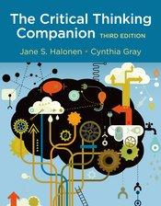
Halonen/Gray, The Critical Thinking Companion for Introductory Psychology, 3e
Designed to support any introduction to psychology or critical thinking course, this engaging and concise companion takes an active learning approach to developing students’ critical thinking skills. The authors include a wealth of hands-on exercises that span the spectrum of topics in psychology from neuroscience, cognitive, social, abnormal, and developmental psychology.

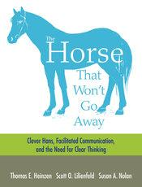
Heinzen/Lilienfeld/Nolan, The Horse That Won’t Go Away, 1e
In The Horse That Won’t Go Away, Tom Heinzen, Scott Lilienfeld, and Susan Nolan explore the confounding story of Clever Hans and how we continue to be deceived by beliefs for which there is no supporting logic or evidence. From Clever Hans, to the unsupported claims that facilitated communication could allow persons with autism to communicate, to the exaggerated fear of many parents that their child may be kidnapped (the odds of such an event are astronomical), the authors show just how important it is to rely on the scientific method as we navigate our way through everyday life.
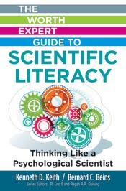
Keith/Beins, Worth Expert Guide to Scientific Literacy: Thinking Like a Psychological Scientist, 1e
Accessible and engaging, and based on fundamental psychological principles, this brief book helps students foster solid habits of scientific thought, learning to apply an empirical attitude and data-driven decision making in their lives. With this increased level of scientific literacy, students will be better able to make sense of complex scientific information they encounter. They will also be able to see through pseudoscientific claims that are not only invalid but potentially harmful.

Zweigenhaft/Borgida, Collaboration in Psychological Science, 1e
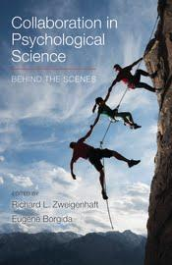
This remarkable collection of essays gives students and other researchers a firsthand look at how collaborative scientific research is done. The 35 contributors here are leading psychological and social scientists with extensive experience working as members of a research team. Each author offers a distinctive perspective on the collaborative research process—its pros and cons, challenges and benefits, practical implications and ethical dilemmas. Each essay focuses on a set of guiding questions:
- What motivated the collaboration?
- What about the collaboration made the research work more effective (or less?)
- Does the substantive domain in which the collaboration occurs shape the nature of the collaboration?
- How have technological advances changed collaboration?
- Are there particular issues that arise for students collaborating with faculty members, or faculty members collaborating with students?

Developmental Psychology

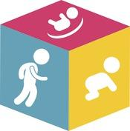
Developing Lives
With Developing Lives, each student provides a personal profile, selects a virtual partner (or chooses to be a single parent) and marks the arrival of their newborn (represented by a unique avatar based on the parents’ characteristics). As the child grows, the student responds to events both planned and unforeseen, making important decisions (nutrition choices, doctor visits, sleeping location) and facing uncertain moments (illness, divorce, a new baby), with each choice affecting how the child grows. Throughout, Developing Lives deepens each student’s attachment and understanding of key concepts in the field with immediate, customized feedback based on child development research.

Child Development
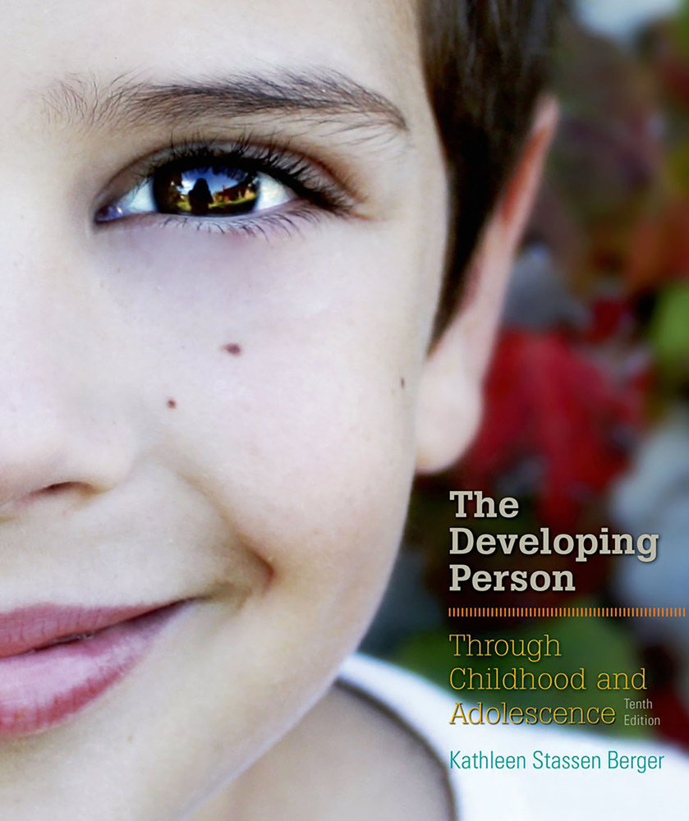
Berger, The Developing Person Through Childhood and Adolescence, 10e and Berger, The Developing Person Through Childhood, 7e

Exceptional in its currency, global in its cultural reach, Kathleen Berger’s portrait of the scientific investigation of childhood and adolescent development helps bring an evolving field into the evolving classroom. Guided by Berger’s clear, inviting authorial voice, and page after page of fascinating examples from cultures around the world, students see how classic and current research, and the lives of real people, shape the field’s
core theories and concepts. In addition to Kathleen Berger’s exhaustive updating of the research, this edition is notable for its thorough integration of assessment throughout (learning objectives, assessments after each section, expanded end-of-chapter quizzes) all aligned with national standards. New edition coming in Spring!

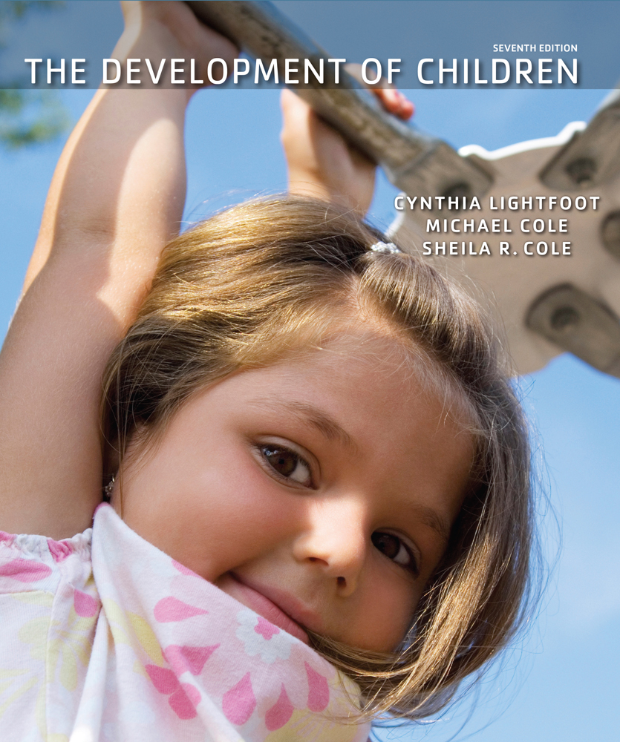
Lightfoot/Cole/Cole, The Development of Children, 7e
The Development of Children has long been acclaimed for its authoritative chronological exploration of how the lives of children are shaped by biological and cultural factors. In this thoroughly updated new edition, lead author Cynthia Lightfoot builds on the legacy of original authors Michael and Sheila Cole, offering a lively, engaging, and always accessible examination of child development as a process involving the whole child within multiple, mutually influencing contexts. Throughout, the emphasis is on how the interaction of biology and culture contributes both to the universal pathways of development shared by all children and to the diverse developmental patterns that unfold in the lives of individual children. New edition coming in Spring!

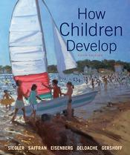
Siegler/Saffran/Eisenberg/DeLoache/Gershoff,
How Children Develop, 5e
How Children Develop has established itself as the topically organized textbook teachers and researchers trust for the most up-to-date perspectives on child development. The authors, each a well-known scientist and educator—have earned that trust by introducing core concepts and impactful discoveries with an unparalleled integration of theory, cultural research, and applications, all in a style that is authoritative yet immediately understandable and relevant to students. “Closer Look” applications throughout the book highlight exciting new research and a richer integration between the book and its interactive study features in LaunchPad make it more interactive than ever.

Lifespan Development
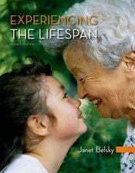
Belsky, Experiencing the Lifespan, 4e
Exceptionally well-loved by instructors and students who've used it, Janet Belsky's text, written in her signature engaging style and voice, offers a fresh, remarkably brief way to understand the experience of human development throughout the lifespan. It gives students an immediate and practical grounding in the field’s basic concepts, guiding them from underlying research to practical applications, in a highly conversational style, with pedagogy that reinforces learning, and with examples drawn from an extraordinarily broad range of cultures throughout the world. And with its dedicated version of Worth’s online course space, LaunchPad, this edition becomes a fully integrated print/interactive resource.

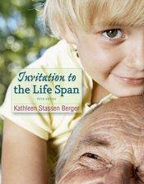
Berger, Invitation to the Life Span, 3e
In 15 concise chapters, the new edition of Invitation to the Life Span incorporates a wide range of new research, especially in fast-moving areas such as brain development and psychopathology, while taking advantage of innovative new tools for media-centered teaching and learning, including seamless integration with the book's dedicated version of Worth's online course space, LaunchPad. But throughout, as always, the signature voice of Kathleen Berger ties it all together, with relatable explanations of scientific content, wide ranging cultural examples, and skill-building tools for sharper observation and critical thinking.

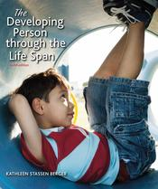
Berger, The Developing Person Through the Life Span, 10e
Kathleen Berger’s acclaimed survey of developmental psychology across the life span is always up to date, always inclusive of cultures from every corner of the globe, and always compelling in the way it shows students the everyday relevance of field’s theories, ideas, and discoveries. New critical thinking and applications-based pedagogy and child development and nursing career appendices has students thinking about real-world experiences and implications of what they’re learning. With its new edition, the text becomes a more deeply integrated text/media resource than ever, with the book and its dedicated version of LaunchPad combining seamlessly to enhance the learning experience. But driving that experience, as always, is the clear, engaging voice of Kathleen Berger, revealing the connections between the study of development across all stages of life and lives that students actually live.
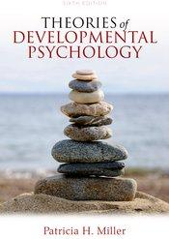

Theories of Development

Miller, Theories of Developmental Psychology, 6e
Always reflective of the latest research and thinking in the field, Patricia Miller’s acclaimed text offers an ideal way to help students understand and distinguish the major theoretical schools of child development. This fully updated new edition includes a new focus on biological theories of development.

Abnormal Psychology

Abnormal Psychology
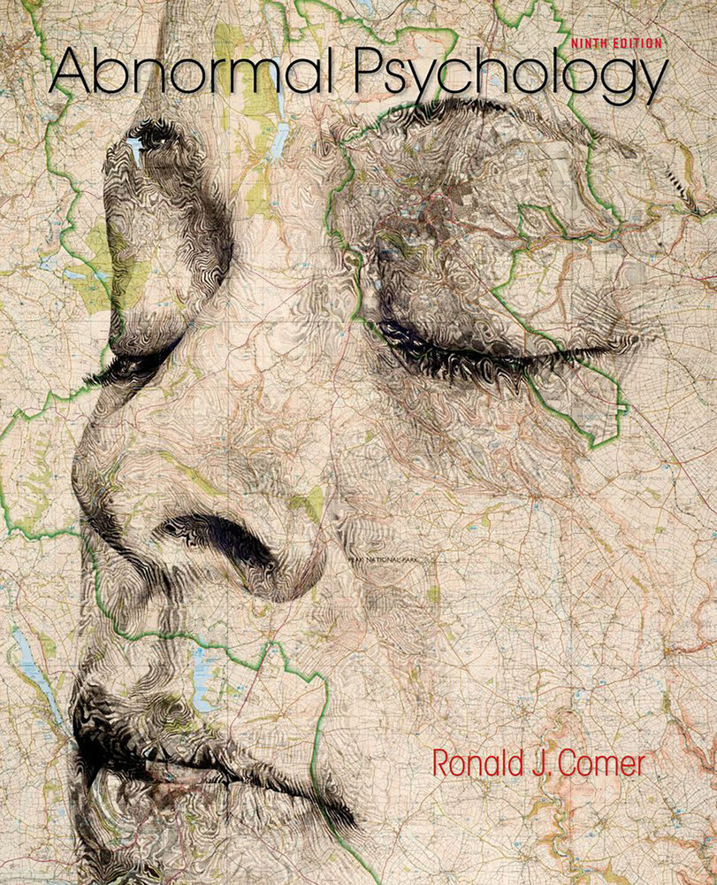
Comer, Abnormal Psychology, 9e
With its signature integrated coverage of theory, diagnosis, and treatment, and remarkably inclusive cross-cultural perspective, this new edition of Comer’s widely adopted textbook shows students where the study and treatment of psychological disorders stand today. In addition to a thorough updating, the new edition includes:
- Fully updated Table of Contents for DSM-5, including a full infographic on DSM-5 in the endpapers.
- A new digital activity, Clinical Choices: With these eleven interactive case studies in LaunchPad, students take on the role of clinical psychologist, engaging with online "clients" to identify psychological disorders (based on DSM-5 criteria) and think critically about diagnosis and treatment options. Try it here: http://www.macmillanhighered.com/Catalog/Product.aspx?title=abnormalpsychology-ninthedition-comer&tab=about&feature=overview&cparam1=ektron&contentid=17892#tab
- New Infographics: These large storyboard-style graphics combine images and step-by-step explanations to portray important abnormal psychology concepts visually, in a way that helps students understand complex topics and prepare for exams.
- New MindTech feature: This feature considers the impact of tech on diagnosis and manifestation of mental illness in today’s world.
New edition coming in Spring!

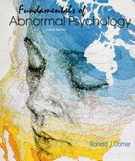
Comer, Fundamentals of Abnormal Psychology, 8e
In his brief text, Comer draws on his experience as an educator, researcher, and practicing therapist to cover the basic concepts of psychopathology in a way that is scientifically sound, widely accessible, and extraordinarily empathetic. The new edition features Comer’s signature integration of theory, diagnosis, and treatment, as well as his broadly inclusive cross-cultural perspective. In addition to updated coverage throughout, it offers a number of features created under Comer’s supervision that bring fresh, effective new teaching approaches to the text and accompanying media, including infographics (large-scale step by step illustrations of complex concepts), video case studies and activities, and the new online feature, Clinical Choices, which puts students in the role of a clinical psychologist.

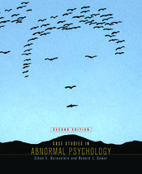
Gorenstein/Comer, Case Studies in Abnormal Psychology, 2e
Fully updated for DSM-5, this exciting revision complements the abnormal psychology course by providing 17 case histories based on the authors' clinical experiences. Each case study goes beyond DSM-5 diagnosis to describe the individual's history and symptoms, a theoretical discussion of treatment, a specific treatment plan, the actual treatment conducted, and assessment questions for students. The casebook also provides three "You Decide" cases -- written without diagnosis or treatment, so students can identify disorders and suggest appropriate therapies. This new edition adds assessment questions to the end of each case and also features three brand new cases: hoarding, somatic symptom disorder, and gender dysphoria.

Experimental Psychology

Research Methods
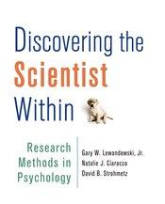
Lewandowski/Ciarocco/Strohmetz, Discovering the Scientist Within, 1e
In this breakthrough first edition, authors Gary Lewandowski, Natalie Ciarocco, and David Strohmetz draw on their extensive classroom experiences to introduce research methodology in a highly effective, thoroughly engaging new way, maximizing students’ familiarity with every step of the process. For the first time in a methods text, each design chapter follows a single study from ideation to writing for publication, with students researching an intriguing question emerging from a chapter-long case study. Also for the first time in a methods text, each design chapter models the entire research process, so students get multiple opportunities to experience that process start to finish.
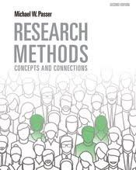
Passer, Research Methods: Concepts and Connections, 2e
With over two decades of classroom experience, Michael Passer knows how to guide students through the ins and outs of research methods in ways they can actually understand and put into practice. In this remarkable text, Passer’s experience leads to chapters filled with clear explanations, resonant examples, and contemporary research from across the breadth of modern psychology, all while anticipating common questions and misunderstandings. This edition features new full-page infographics summarizing key concepts and fully updated research, as well as Concept Checks, Knowledge Assessment, and Critical Thinking and Application questions in each chapter enable students to test their understanding of the concepts as they read.

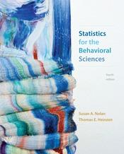
Behavioral Statistics

Nolan/Heinzen, Statistics for the Behavioral Sciences, 4e
Nolan and Heinzen offer an introduction to the basics of statistics that is uniquely suited for behavioral science students, with coverage anchor to real-world stories, a highly visual approach, helpful mathematical support, and step-by-step examples. The new edition focuses on emerging trends that are redefining contemporary behavioral statistics, while adding an remarkable new online feature, Choosing the Correct Statistical Test, in the book’s online component, LaunchPad.

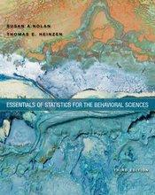
Nolan/Heinzen, Essentials of Statistics for the Behavioral Statistics, 3e
With captivating storytelling, real-world examples, image-and graphic-rich design, accessible mathematics, and step-by-step worked examples, Nolan and Heinzen introduce students to the why and how of statistical practice in the behavioral sciences, while helping them break through common barriers to success in the course.This new edition of their briefer textbook offers fresh exercises throughout, stronger reinforcement of the material’s relevance and mathematical requirements, more help with creating visual displays, and a dramatic expansion of its integrated online tools and activities in LaunchPad.
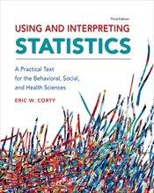
Corty, Using and Interpreting Statistics, 3e
Eric Corty’s engaging textbook is exceptionally well suited for behavioral science students studying statistical practice in their field for the first time. An award-winning master teacher, Corty speaks to students in their language, with an approachable voice that conveys the basics of collecting and understanding statistical data step by step. Examples come from the behavioral and social sciences, as well as from recognizable aspects of everyday life to help students see the relevance of what they are studying.

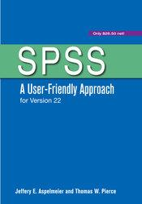
Aspelmeier/Pierce, SPSS: A User-Friendly Approach for Version 22
In this comprehensive introduction to SPSS, Jeffery Aspelmeier and Thomas Pierce explain the procedures and concepts of SPSS in a way that is easy to understand and vividly illustrated with cartoon-based scenarios. SPSS: A User-Friendly Approach goes beyond providing instructions on the mechanics of conducting data analysis and develops a student’s conceptual and applied understanding of quantitative techniques. Readers also learn how to complete a procedure and ensure that the results are statistically meaningful.

Biological Psychology & Neuroscience

Introduction to Biological Psychology
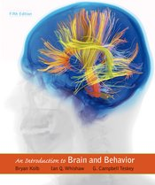
Kolb/Whishaw, An Introduction to Brain and Behavior, 5e
From authors Bryan Kolb and Ian Whishaw, and new coauthor G. Campbell Teskey, An Introduction to Brain and Behavior offers a unique inquiry-based introduction to behavioral neuroscience, with each chapter focusing on a central question (i.e., "How Does the Nervous System Function?"). It also incorporates a distinctive clinical perspective, with examples showing students what happens when common neuronal processes malfunction. Now this acclaimed book returns in a thoroughly up-to-date new edition.

LaunchPad Solo for Neuroscience
The LaunchPad Solo for Neurosicence features 30 interactive tutorials that allow students to see the nervous system in action via dynamic illustrations, animations, and models that demystify the neural mechanisms behind behavior. Videos taken from actual laboratory research enhance students' understanding of how we know what we know, and carefully crafted multiple choice questions make it easy to assign and assess each activity.

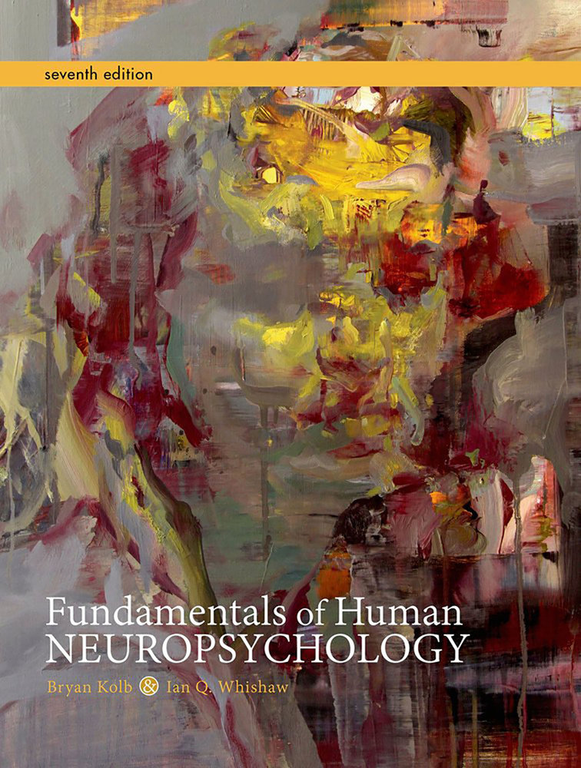
Human Neuropsychology

Kolb/Whishaw, Fundamentals of Human Neuropsychology, 7e
Written by two masterful researchers and educators, Fundamentals of Human Neuropsychology was the first textbook to introduce students to the scientific exploration of human behavior from a neuroscientist’s perspective. With this updated edition, Bryan Kolb and Ian Whishaw again take students to the very forefront of one of the most eventful and impactful areas of scientific inquiry today, making an extraordinary amount of recent research and the real-world impact of those discoveries fascinating and accessible.

Drugs and Behavior
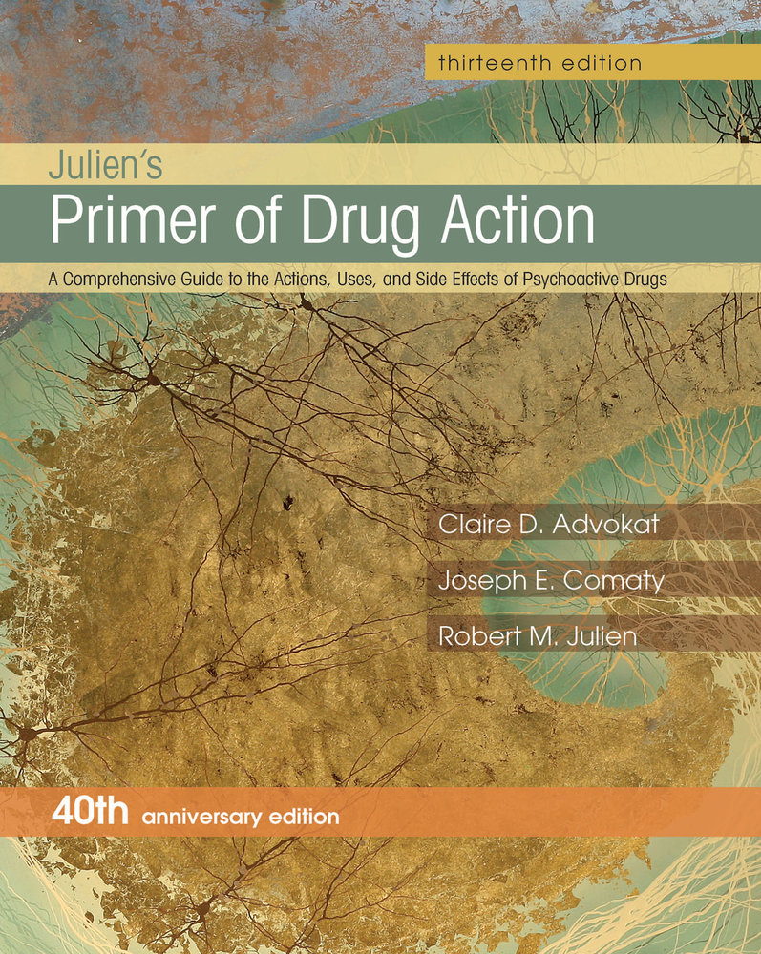
Advokat/Comaty/Julien, A Primer of Drug Action, 13e
In its 40th anniversary edition, A Primer of Drug Action continues to evolve side by side with the field it covers, drawing on the expertise of its authors in medicine, basic science, and clinical science to offer the most current and comprehensive guide to psychopharmacology available. Now with new lead author Claire Advokat of Louisiana State University, the new edition comes with a new introduction to epigenetics, as well as new coverage of desensitization and Supersensitivity, Competitive and Noncompetitive Antagonism, and Polypharmacy and Adverse Reactions and much more.

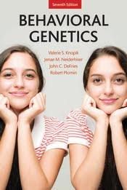
Behavioral Genetics

Knopik/Neiderhiser/DeFries/Plomin, Behavior Genetics, 7e
With its clear and concise presentation, Behavioral Genetics, 7th edition introduces students to the field’s underlying principles, defining experiments, ongoing controversies, and most recent discoveries. The text provides students with an understanding of heredity, its DNA basis, the methods used to discover genetic influence on behavior and identify specific genes. It then examines what is known about genetic influence on cognitive ability, psychopathology, substance abuse, personality, health psychology, and aging. Finally it looks at the future of the field of Behavioral Genetics and area where some of the most exciting development in the Behavioral sciences are being made.

Social & Personality Psychology

Social Psychology

Greenberg/Schmader/Arndt/Landau,
Social Psychology: The Science of Everyday Life
This remarkable new textbook offers a fresh approach to the study of social psychology, integrating theory, research, and applications into a coherent, contemporary portrait of the field that no other available text can match. Drawing on over 50 years of combined teaching and research, Greenberg, Schmader, Arndt, and Landau guide students through the rich diversity of the science of social psychology and its insights into everyday life. The book introduces students to five broad perspectives on human social behavior: social cognition, cultural psychology, evolutionary theory, existential psychology, and social neuroscience. With these perspectives serving as recurring themes, each chapter organically weaves together explanations of theory, research methods, empirical findings, and applications, showing how social psychologists accumulate and apply knowledge toward understanding and solving real-world problems.
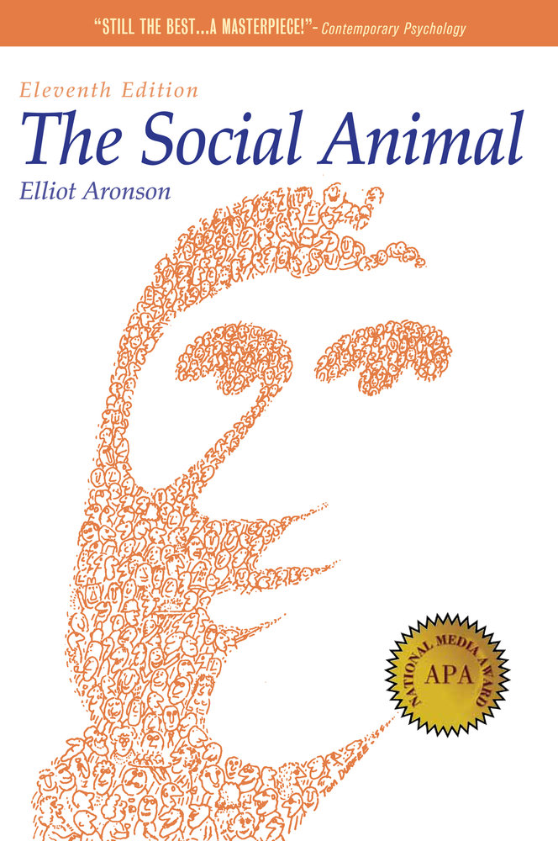
New edition coming in Spring!

Aronson, The Social Animal, 11e
This landmark text offers a brief, compelling introduction to modern social psychology. Through vivid narrative, lively presentations of important research, and intriguing examples, Elliot Aronson probes the patterns and motives of human behavior. Also available: Aronson, Readings About the Social Animal.
New edition coming in Spring!

Special Topics in Social Psychology
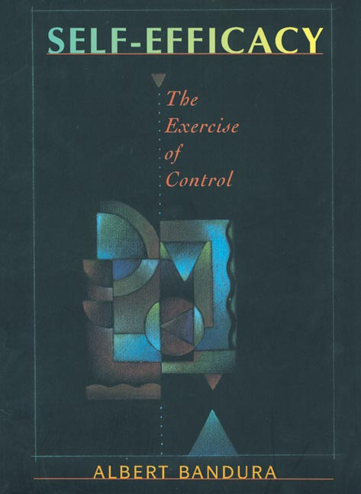
Bandura, Self-Efficacy: The Exercise of Control
The result of over 20 years of research by this renowned psychologist, the book articulates comprehensively Bandura's theory that believing one can achieve what one sets out to do results in a healthier, more effective, and generally more successful life.

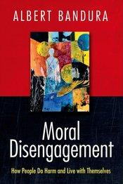
Bandura, Moral Disengagement
How do otherwise considerate human beings do cruel things and still live in peace with themselves? Drawing on his agentic theory, Dr. Bandura provides a definitive exposition of the psychosocial mechanism by which people selectively disengage their moral self-sanctions from their harmful conduct. They do so by sanctifying their harmful behavior as serving worthy causes; they absolve themselves of blame for the harm they cause by displacement and diffusion of responsibility; they minimize or deny the harmful effects of their actions; and they dehumanize those they maltreat and blame them for bringing the suffering on themselves. Dr. Bandura insightfully extends the disengagement of morality to the social-system level through which wide-spread inhumanities are perpetrated. In so doing, he offers enlightening new perspectives on some of the most provocative issues of our time.

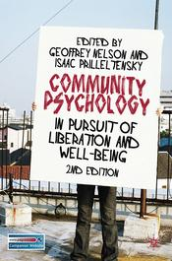
Nelson/Prilleltensky, Community Psychology
The second edition of this highly successful introductory textbook has been updated and expanded to reflect how changes within society have led to developments across the field. The authors offer a fascinating introduction for students, setting out the principles of community psychology as they consider how its roots have helped to shape the goals of liberation and well-being. Following this, the authors look closely at the conceptual, interventional, and research tools of community psychology and how they can be applied in different contexts, the difficulties faced and practical ways to help achieve social justice. Featuring a wide range of critical perspectives, international examples, exercises and additional online resources, this textbook will encourage students to think more critically about the role of psychology in society and about how community psychology can aid in the liberation of oppressed groups to promote social justice and well-being.

Cognition, Learning & Memory

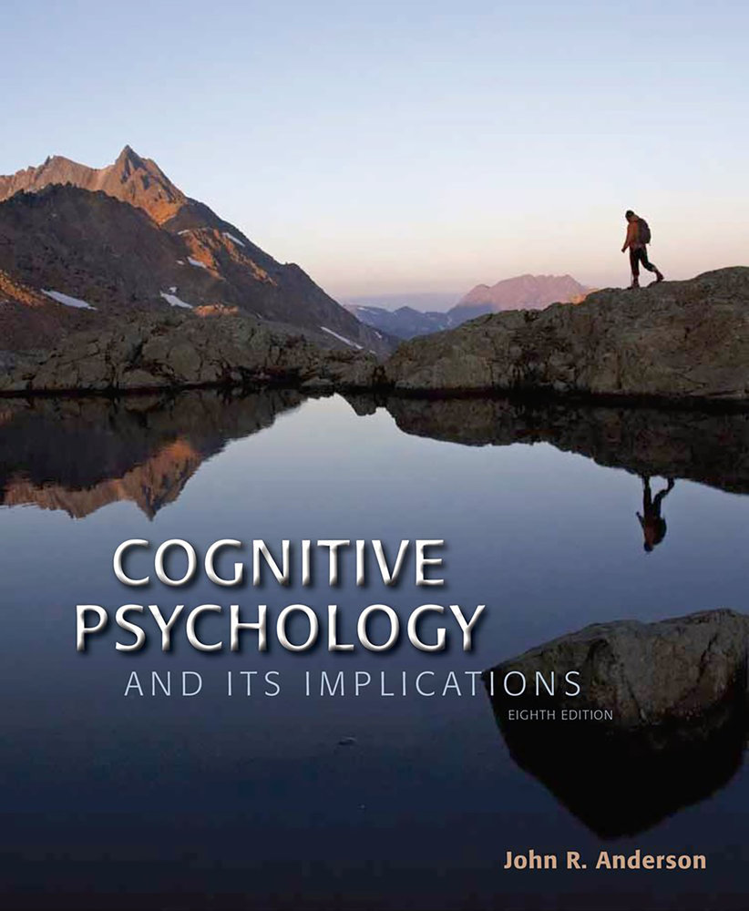
Cognitive Psychology

Anderson, Cognitive Psychology and its Implications, 8e
John R. Anderson has been long been at the forefront of the study of cognition, with accomplishments that have informed the way cognitive psychology is investigated, applied, and taught. With this new edition of his classic textbook, Anderson again takes students to the forefront of the field, incorporating the latest theoretical breakthroughs, research findings, and technological advances, as well as marking the increasing role of neuroscience in the study of cognitive functions. As always, Anderson makes his discussions of higher mental processes concrete and accessible with fascinating examples and clear explanations of the underlying research.

Learning and Memory

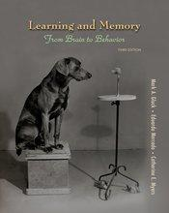
Gluck/Mercado/Myers,
Learning and Memory: From Brain to Behavior, 3e
With its modular organization, consistent chapter structure, and contemporary perspective, this groundbreaking survey is ideal for courses on learning and memory, and is easily adaptable to courses that focus on either learning or memory. Instructors can assign the chapters they want from four distinctive modules (introduction, learning, memory, and integrative topics), with each chapter addressing behavioral processes, then the underlying neuroscience, then relevant clinical perspectives. The book is further distinguished by its full-color presentation and coverage that includes comparisons between studies of human and nonhuman brains.

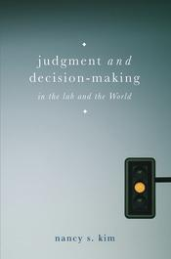
Judgment & Decision Making

Kim, Judgment and Decision Making, 1e
How do we make the judgments that inform our lives? Is there any way of consciously removing bias from the choices we make? What do our everyday personal decisions have in common with those made by groups, companies, and even nations? In this innovative textbook, Nancy Kim presents a multidisciplinary introduction to the dynamic field of judgment and decision-making. Throughout the book, insights from traditional cognitive approaches are combined with findings from fields as diverse as neuropsychology, behavioural economics, social, developmental and clinical psychology, and philosophy. It is an essential companion to any student taking a first course in judgement and decision-making, or a general survey course in cognitive psychology.

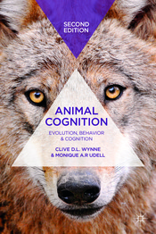

Animal Psychology

Wynne/Udell, Animal Cognition, 2e
A fascinating account of animal intelligence, this engagingly-written text presents a comprehensive survey of contemporary research on animal cognition, from reasoning and communication to perception and problem-solving. This is ideal reading for all those interested in animal behavior and in how much of human cognition is shared by other species.

Language

Kennison, Psychology of Language, 1e
With its highly conversational writing style and helpful pedagogical features, Sheila Kennison’s remarkable new textbook is just right for undergraduates who are new to study of the psychology of language. Kennison addresses all of the traditional topics and foundational concepts that define psycholinguistics, progressing from words to sentences to discourse, but also incorporates chapters that are unique to her approach (How Do Bilinguals Process Their Languages? How Can Language Become Disordered?).

Sensation & Perception

Sensation & Perception

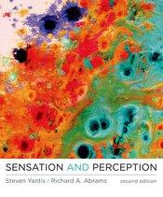
Yantis/Abrams, Sensation and Perception, 2e
Like no other text, Sensation and Perception expertly introduces students to how we sense and perceive the world around us. Using clear and detailed explanations and highly effective illustrations the text illuminates the connections between mind, brain, and behavior in the realm of sensation and perception. Seamlessly integrating classic findings with cutting edge research in psychology, physiology and neuroscience Sensation and Perception 2e explores what questions researchers are seeking to answer to today and the methods of investigation they are using. Sensation and Perception, Second Edition, now includes 15 chapters, including separate chapters on motion perception, perception for action, olfaction, and gustation, and a new appendix on noise and signal detection theory. The new edition introduces new coauthor Richard A. Abrams (Washington University).

LaunchPad Solo for Sensation & Perception
LaunchPad Solo for Sensation and Perception offers students the opportunity to work like researchers, manipulating experimental factors and interpreting consequences as they go. The 50 demonstration activities here—on topics ranging from binocular disparity to change blindness—were developed by a team of experts, including Steven Yantis, Richard Abrams (Washington University, St. Louis), Larence Becker (Salisbury University) and Robert Rauchenberger.

Forensic & Legal Psychology

Forensic & Legal Psychology

Costanzo/Krauss, Forensic and Legal Psychology, 3e
Drawing on a combined three decades of teaching experience, Costanzo and Krauss help students explore the fascinating intersections where psychology and the law meet, in an excitingly written textbook that presents the latest research in the context of dozens of real cases.
As before, the new edition draws on extensive research in social, cognitive, clinical, and developmental psychology to explore virtually every aspect of the legal system studied by psychologists, emphasizing the ways research and theory deepen our understanding of key participants (e.g., criminals, police, victims, lawyers, witnesses, judges, and jurors) and basic psychological processes (e.g., decision-making, persuasion, perception, memory, and behavior change).

Industrial & Organizational Psychology

Industrial & Organizational Psychology
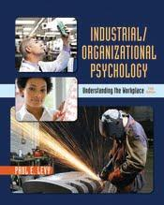
Levy, Industrial Organizational Psychology: Understanding the Workplace, 5e
Written by a leading researcher in one of the nation’s top I/O programs, Paul Levy’s text has long been acclaimed for its concise, research-based approach, and personable writing style. The new edition again offers a thoroughly contemporary perspective on the field, with the latest research and new ways for students to explore what’s happening in I/O psychology today.

Health Psychology
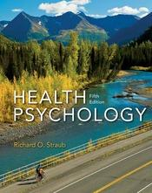

Health Psychology

Straub, Health Psychology: A Biopsychosocial Approach, 5e
Richard Straub’s Health Psychology shows students how psychology and health are interconnected. Using real world examples, Straub encourages students to make meaningful connections between the science of health psychology and their own everyday experience. Health Psychology is comprehensive in its approach and incorporates the latest research as it examines the field’s main ideas and models a scientific way of thinking about those ideas.

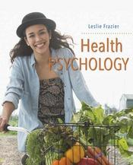
Fraizer, Health Psychology, 1e
Health Psychology provides a science and empirically-based approach to health psychology. It goes beyond other mainstream textbooks by introducing students to global and cross-cultural health issues, covering cutting-edge scientific and medical topics in ways that students can understand. The author integrates core theory, research, and practice in an engaging and practical way.
The author integrates the biopsychosocial perspective, building on traditional content and topics in order to aid student understanding, interest, and learning. This textbook incorporates engaging applications, case studies and frequent examples, clear and thorough explanations, and a student-friendly tone. It insists on the implications of positive and negative health behaviors for a student’s life. The author also provides an emphasis on developmental influences on health.
Within each chapter, thought-provoking issues drawn from the World Health Organization and other international health organizations highlight our current understanding of health and wellness. Chapters open with personal profiles, ending with how the chapter addresses the questions that these raise.
LaunchPad Solo for Health Psychology is an online website that offers a variety of tutorials, activities, and additional study aids, including quizzes, video activities, and interactive assessments. These resources help students study and understand the material, and they also provide instructors with useful tips on interesting ways of presenting the material in class.

Evolution

Evolution
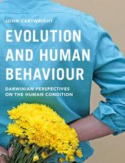
Cartwright, Evolution & Human Behavior, 3e
Our experience of the world is driven by processes common to all animals: growth, survival, reproduction and death. Evolution and Human Behaviour explores the complexities of the human experience through the lens of Darwinism, drawing on a long and vibrant tradition of different theories and interpretations. This textbook offers a compelling synthesis of key concepts, addressing human thought, feeling and behaviour in fundamental evolutionary terms.
Written for students of psychology, human biology, ethology, anthropology and human behavioural ecology, this is an essential introduction for anyone who wishes to understand how human behaviour has evolved.

Learn more about blogs, webinars, and resources for your class on the Psychology Community.
https://community.macmillan.com/community/the-psychology-community

